2023-2024 COURSE SYLLABUS
Coding for Fintech

Teacher: David Turner | Phone Number: 678-310-7166
Room Number: A413 | Email: dturner@atlanta.k12.ga.us
Semester: Fall 2023 | Tutorial Days: Mondays
Textbook: Online Sources | Tutorial Hours: 4-5 pm
Website: https://dcturn20.weebly.com/ | Tutorial Location: Hybrid/ Zoom/A413

Course Description:

This course covers the design and development of dynamic, data-driven financial applications using client- and server-side architecture. It focuses on various application development techniques for user and mobile friendly design. It also introduces how to develop financial applications conforming to the industry standards. Various forms of technologies and internet research will be highlighted to expose students to the resources available on financial technology (FinTech). In this course students will develop a functional model financial application across the full development stack from model to view, using the Model-View-Controller (MVC) programming paradigm.

Employability skills are integrated into activities, tasks, and projects throughout the course standards to demonstrate the skills required by business and industry. Competencies in the co-curricular student organization, Future Business Leaders of America (FBLA), are integral components of the employability skills standard for this course. Coding for FinTech is the final course in the FinTech pathway in the Finance Career Cluster. Students enrolled in this course should have successfully completed Introduction to Financial Technology and Financial Technologies and Services.
Prerequisite:

Course Content Standard - (www.georgiastandards.org): Coding-for-FinTech (1).pdf

Course Outline:

Week 1: | Develop scripting code using Javascript, Python, or other scripting languages
Week 2: | Analyze existing industry Application Programming Interfaces (API) used in financial services code.
Week 3: | Write a sample API that models financial services code used in industry.
Week 4: | Identify security protocols used in industry to secure financial transactions and records, including encryption, User Authentication, two-part authentication, and biometrics
Week 5: | Identify protections against intrusion such as cross-site scripting, Structured Query Language (SQL) injection, denial of service, and other forms of attack
Week 6: | Identify anti-money laundering, counterterrorism, and social engineering attacks involving the movement of money
Week 7: | Create a database that models a financial system
Week 8: | Demonstrate knowledge of Structured Query Language (SQL) access to a database table
Week 9: | Create and edit a database-stored procedure.
Week 10: | Connect a computer program to a database using a connection string that is not hard coded into source code.
Week 11: | Program a controller that safely connects an application’s data model to appropriate user views using an industry standard programming language, (e.g., C#, .NET Core, Ruby on Rails).
Week 12: | Create and summarize the user validation login system for the application
Week 13: | Investigate real-world banking applications and develop a model application’s UI.(5.1)
Week 14: | Demonstrate and explain use of UI platforms such as Bootstrap, Rails, or other interface models or program the interface designed in element 5.1.
Week 15: | Review industry financial security standards including Sarbanes Oxley Act (SOX), Payment Card Industry Data Security Standard (PCI DSS), Gramm-Leach-Bliley Act (GLBA), Federal Financial Institutions Examination Council (FFIEC), and others
Week 16: | Identify and explain the use and implementation of software security protocols related to digital identity such as Multi-Factor Authentication (MFA), Google Authenticator, Microsoft Authenticator, Open Authorization (OAuth) APIs that integrate with each other, use of tokenization/Anonymization of Pay Card Industry (PCI) and Personally Identifying Information (PII) data, and PCI/DSS.
Week 17: | Detail the use of consumer (user) disclosures and how it relates to privacy and information security
Week 18: | Discuss accessibility issues surrounding e-commerce and banking

Evaluation and Grading:

Course Components | Weights | Grading Scale
Classwork (grading floor of 50) | 40% | 100-90 | A
Summative | 60% | 89-80 | B
TOTAL | 100% | 79-70 | C
 |  | 69-0 | F
 |  | *Not Evaluated | *NE
*NE (not evaluated): Tasks may be entered into the “Classwork” category as not evaluated/not graded/unweighted in order to record formative tasks included in instruction.

- Grading:
  - Classwork category: Grading floor of 50
    - “Missing” calculated as 50
    - Graded tasks with earned scores of 50 or below are entered as 50.
  - Summative category:
    - Students’ grades are entered as earned.
    - Reassessment opportunities are required for all students on summative tasks (including tests and quizzes) when they score 69% or below. This reassessment will be a newly generated teacher assessment and the reassessment score will replace the original score if higher. Students have two opportunities for reassessment; if students do not demonstrate mastery after the second reassessment, the teacher will refer the student for additional support.

- LATE ASSIGNMENTS: A late assignment is defined as work submitted after the teacher collected the assignment. Students who submit late work by the late work deadlines (see below) will receive full credit for the late assignments. Teachers should enter an "M" into IC if an assignment is missing. If the student turns the assignment in prior to the late work deadline, the assignment will be scored based on mastery of the standard(s) and entered into the grade book.

Students with late assignments must submit work by the deadlines below:

Makeup Work/Reassessment Deadlines 2023-2024 School Year

First semester  August 1-December 15, 2023 | Midpoint: 10/6 | Deadline 9/25 for assignments 8/1—9/22
 |  | Deadline 12/4 for assignments from 9/25-12/1
Second semester  January 3-May 24, 2024 | Midpoint: 3/15 | Deadline 3/4 for assignments from 1/3-3/1
 |  | Deadline 5/13 for assignments from 3/4-5/10

Campus Portal for Parents and Guardians (class schedules, attendance records, grades):

https://ic.apsk12.org/campus/portal/atlanta.jsp

To activate your account/receive your login activation key, please contact Mr. Montero at bmontero@atlanta.k12.ga.us.

Schoology is a K-12 educational learning management system and an all-in-one platform for teaching, learning, assessing, and reporting grades and data. The goal for an LMS is to allow a school to have a central piece of technology to be the platform for communicating with students, teachers, families, and administration. Students access Schoology through MyBackpack.

Required Materials:

➢ pen/pencil

➢ flash drive

➢ Headphone or Earbuds

School-wide Behavioral Expectations: Be present, be respectful, be responsible, be on task, be peaceful, be productive problem solvers.

Classroom Expectations:

➢ All virtual and hybrid classes will be held on zoom.us.
➢ Arrive ON time (If you are early = on time, On time = late, Late = unemployed)
➢ ACTIVELY participate
➢ Remain on task
➢ Embrace the use of the 5Cs (communication, collaboration, creativity, critical thinking, &
citizenship)
➢ Cellphones must be locked up during class, a secure lockbox is located at the front of the
room.
➢ No Eating & Drinking during class

Academic Dishonesty:
It is the responsibility of every student and employee to exhibit honesty, trust, fairness, and respect in all academic pursuits. Cheating, plagiarism, and other acts of academic dishonesty are strictly prohibited. Students who exhibit academic dishonesty will face consequences ranging from detention, in-school suspension, out-of-school suspension/disciplinary tribunal/assignment to alternative school. Students who cheat on standardized tests such as the Milestones risk their exams being invalidated. Examples of academic dishonesty include but are not limited to: copying or "borrowing" from another source and submitting it as one's own work; seeking or accepting unauthorized assistance on tests, projects or other assignments; fabricating data or resources; providing or receiving test questions in advance without permission; or working collaboratively with other students when individual work is expected.

Academic Dishonesty with a Device:
Use of a cellular phone without the consent of a school administrator or school staff during a test, quiz, or completion of a graded assignment is considered cheating and is strictly prohibited.

School-wide Expectations:

MASTERY LEARNING: With mastery learning, a unit of material is taught, and student understanding is evaluated before students are able to move on to the next unit. Students who have not shown mastery for a particular unit will receive feedback and support in reaching mastery. They may be given practice exercises, study guides, group work or complementary resources to help them improve and achieve mastery. Students who demonstrate mastery of the content for a particular unit early are given enrichment exercises like special projects, tasks or academic games to further or broaden their knowledge of the material.

For additional help, Tutor ATL info: https://tutoratl.org

PROGRESS REPORTS: Parents and guardians are informed when students are making unsatisfactory progress in classes. Poor performance will be reported to parents and guardians as soon as problems are evident. Progress reports with plans for remediation will be provided for all students making unsatisfactory progress, and parent-guardians conferences must be scheduled. Unsatisfactory grades should never come as a surprise to parents, guardians, or students. Also, see Board Policy Administrative Regulation IHA-R(1) under “Students in danger of not meeting academic expectations” for further information. Teachers will:

- Contact parents/guardians early in the semester if academic, attendance, or behavioral difficulties are apparent.
- Notify the counselor, Student Support Team (SST)/Response to Intervention (RTI) Chair, and/or an assistant principal of serious problems that are affecting classroom performance.
- Set up parent conferences as necessary.

ATHLETIC ELIGIBILITY: Students wanting to participate in athletic programs governed by the GHSA and extracurricular activities must meet eligibility requirements to participate. The Athletic Director (and the Extracurricular Activities sponsors) will collaborate with teachers to monitor and to identify students in danger of failing courses. A master list of students participating in extracurricular activities and athletics under the auspices of the GHSA will be available to all staff.

Our Vision: A high-performing school where educators inspire, families engage, and students love to learn.
Our Mission: Every student will graduate college and career ready with a dedication to community involvement and service.
Midtown Graduate Profile (5 Cs): Creative, collaborative, critical thinker, communicative, and a good citizen.

Midtown Community Resource Guide: https://www.atlantapublicschools.us/domain/11155

For Mental Health Crisis you may call the Georgia Crisis & Access Line at 1-800-715-4225.
Resources:
https://suicidepreventionlifeline.org/
https://namiga.org/georgia-crisis-and-access-line/
https://www.crisistextline.org

See Something Say Something Anonymous Line: 1-844-5-SAYNOW

School Counseling Site for Resources/Documents: https://www.atlantapublicschools.us/Page/46013

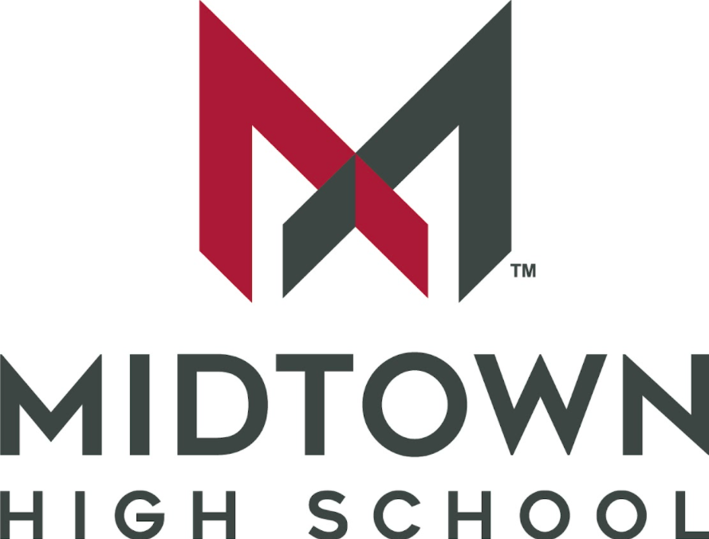

Receipt of Syllabus
Course Name: Coding for Fintech
Teacher Name: David Turner

______________________________ __________________________________
Student Signature Parent/Guardian Signature

______________________________ __________________________________
Date Date

