2023-2024 COURSE SYLLABUS
Financial Technology and Services

Teacher: David Turner | Phone Number: 678-310-7166
Room Number: A413 | Email: dturner@atlanta.k12.ga.us
Semester: Fall 2023 | Tutorial Days: Monday
Textbook: Online resources | Tutorial Hours: 4-5 pm
Website: https://dcturn20.weebly.com/ | Tutorial Location: Hybrid/ Zoom/A413

Course Description:

This course covers the foundations of financial technologies and services. The
course focuses on the usage of technology that powers financial ecosystems, digital finance platforms, mobile payments, and digital asset management. Students will explore the characteristics and functions of electronic and mobile payment systems. Various forms of technologies and internet research will be highlighted to expose students to the resources available on financial technology (FinTech).

Employability skills are integrated into activities, tasks, and projects throughout the course standards to demonstrate the skills required by business and industry. Competencies in the co-curricular student organization, Future Business Leaders of America (FBLA), are integral components of the employability skills standard for this course. Financial Technologies and Services is the second course in the FinTech pathway in the Finance Career Cluster. Students enrolled in this course should have successfully completed Introduction to Financial Technology.

Prerequisite:
Introduction to Financial Technology

Course Content Standard - (www.georgiastandards.org): file:///C:/Users/harkc/OneDrive/Documents/Financial-Technologies-and-Services%20(1).pdf

Course Outline:

Week 1: | Describe the FinTech landscape and how it has evolved since the introduction of smartphones.
Week 2: | Identify and summarize which fundamental technologies are driving the biggest changes in the  financial industry.
Week 3: | Evaluate and analyze the process that powers electronic transaction business ecosystems.
Week 4: | Compare and contrast various legacy and digital financial services platforms to determine the need to migrate to digital finance platforms.
Week 5: | Describe ways to achieve efficient financial services migration to digital platforms.
Week 6: | Analyze transactional data and describe how it is used to develop customer intelligence.
Week 7: | Analyze blockchain technology and explain how it facilitates fast, secure, low-cost payment  processing.
Week 8: | Demonstrate how the emergence of digital finance extends from customer experience and operational efficiency to big data and analytics
Week 9: | Explain how robotics and artificial intelligence (AI) are applying key pressure points, reducing costs, and mitigating risks in the financial services industry.
Week 10: | Define digital asset management and compare examples researched via Internet.
Week 11: | Define digital trade and explain key barriers.
Week 12: | Describe how digital investments are made and provide examples within FinTech
Week 13: | Describe how robo-advising and AI are shaping (affecting) the FinTech services landscape
Week 14: | Describe the process for creating an automated budget, and create an automated budget using spreadsheet software.
Week 15: | Describe the structure of the United States electronic payment systems and demonstrate the different ways money can move throughout the financial services systems
Week 16: | Evaluate how and why blockchain, without proper investment, can have detrimental effects on speed and cost for cross-border electronic payment systems.
Week 17: | Analyze how cryptocurrency has revolutionized the accessibility of electronic and mobile payments
Week 18: | Compare and contrast the different types of mobile and digital wallets.

Evaluation and Grading:

Course Components | Weights | Grading Scale
Classwork (grading floor of 50) | 40% | 100-90 | A
Summative | 60% | 89-80 | B
TOTAL | 100% | 79-70 | C
 |  | 69-0 | F
 |  | *Not Evaluated | *NE
*NE (not evaluated): Tasks may be entered into the “Classwork” category as not evaluated/not graded/unweighted in order to record formative tasks included in instruction.

- Grading:
  - Classwork category: Grading floor of 50
    - “Missing” calculated as 50
    - Graded tasks with earned scores of 50 or below are entered as 50.
  - Summative category:
    - Students’ grades are entered as earned.
    - Reassessment opportunities are required for all students on summative tasks (including tests and quizzes) when they score 69% or below. This reassessment will be a newly generated teacher assessment and the reassessment score will replace the original score if higher. Students have two opportunities for reassessment; if students do not demonstrate mastery after the second reassessment, the teacher will refer the student for additional support.

- LATE ASSIGNMENTS: A late assignment is defined as work submitted after the teacher collected the assignment. Students who submit late work by the late work deadlines (see below) will receive full credit for the late assignments. Teachers should enter an "M" into IC if an assignment is missing. If the student turns the assignment in prior to the late work deadline, the assignment will be scored based on mastery of the standard(s) and entered into the grade book.

Students with late assignments must submit work by the deadlines below:

Makeup Work/Reassessment Deadlines 2023-2024 School Year

First semester  August 1-December 15, 2023 | Midpoint: 10/6 | Deadline 9/25 for assignments 8/1—9/22
 |  | Deadline 12/4 for assignments from 9/25-12/1
Second semester  January 3-May 24, 2024 | Midpoint: 3/15 | Deadline 3/4 for assignments from 1/3-3/1
 |  | Deadline 5/13 for assignments from 3/4-5/10

Campus Portal for Parents and Guardians (class schedules, attendance records, grades):

https://ic.apsk12.org/campus/portal/atlanta.jsp

To activate your account/receive your login activation key, please contact Mr. Montero at bmontero@atlanta.k12.ga.us.

Schoology is a K-12 educational learning management system and an all-in-one platform for teaching, learning, assessing, and reporting grades and data. The goal for an LMS is to allow a school to have a central piece of technology to be the platform for communicating with students, teachers, families, and administration. Students access Schoology through MyBackpack.

Required Materials:

➢ pen/pencil
➢ flash drive
➢ Headphone or Earbuds

School-wide Behavioral Expectations: Be present, be respectful, be responsible, be on task, be peaceful, be productive problem solvers.

Classroom Expectations:

➢ All virtual and hybrid classes will be held on zoom.us.
➢ Arrive ON time (If you are early = on time, On time = late, Late = unemployed)
➢ ACTIVELY participate
➢ Remain on task
➢ Embrace the use of the 5Cs (communication, collaboration, creativity, critical thinking, &
citizenship)
➢ Cellphones must be locked up during class, a secure lockbox is located at the front of the
room.
➢ No Eating & Drinking during class

Academic Dishonesty:
It is the responsibility of every student and employee to exhibit honesty, trust, fairness, and respect in all academic pursuits. Cheating, plagiarism, and other acts of academic dishonesty are strictly prohibited. Students who exhibit academic dishonesty will face consequences ranging from detention, in-school suspension, out-of-school suspension/disciplinary tribunal/assignment to alternative school. Students who cheat on standardized tests such as the Milestones risk their exams being invalidated. Examples of academic dishonesty include but are not limited to: copying or "borrowing" from another source and submitting it as one's own work; seeking or accepting unauthorized assistance on tests, projects or other assignments; fabricating data or resources; providing or receiving test questions in advance without permission; or working collaboratively with other students when individual work is expected.

Academic Dishonesty with a Device:
Use of a cellular phone without the consent of a school administrator or school staff during a test, quiz, or completion of a graded assignment is considered cheating and is strictly prohibited.

School-wide Expectations:

MASTERY LEARNING: With mastery learning, a unit of material is taught, and student understanding is evaluated before students are able to move on to the next unit. Students who have not shown mastery for a particular unit will receive feedback and support in reaching mastery. They may be given practice exercises, study guides, group work or complementary resources to help them improve and achieve mastery. Students who demonstrate mastery of the content for a particular unit early are given enrichment exercises like special projects, tasks or academic games to further or broaden their knowledge of the material.

For additional help, Tutor ATL info: https://tutoratl.org

PROGRESS REPORTS: Parents and guardians are informed when students are making unsatisfactory progress in classes. Poor performance will be reported to parents and guardians as soon as problems are evident. Progress reports with plans for remediation will be provided for all students making unsatisfactory progress, and parent-guardians conferences must be scheduled. Unsatisfactory grades should never come as a surprise to parents, guardians, or students. Also, see Board Policy Administrative Regulation IHA-R(1) under “Students in danger of not meeting academic expectations” for further information. Teachers will:

- Contact parents/guardians early in the semester if academic, attendance, or behavioral difficulties are apparent.
- Notify the counselor, Student Support Team (SST)/Response to Intervention (RTI) Chair, and/or an assistant principal of serious problems that are affecting classroom performance.
- Set up parent conferences as necessary.

ATHLETIC ELIGIBILITY: Students wanting to participate in athletic programs governed by the GHSA and extracurricular activities must meet eligibility requirements to participate. The Athletic Director (and the Extracurricular Activities sponsors) will collaborate with teachers to monitor and to identify students in danger of failing courses. A master list of students participating in extracurricular activities and athletics under the auspices of the GHSA will be available to all staff.

Our Vision: A high-performing school where educators inspire, families engage, and students love to learn.
Our Mission: Every student will graduate college and career ready with a dedication to community involvement and service.
Midtown Graduate Profile (5 Cs): Creative, collaborative, critical thinker, communicative, and a good citizen.

Midtown Community Resource Guide: https://www.atlantapublicschools.us/domain/11155

For Mental Health Crisis you may call the Georgia Crisis & Access Line at 1-800-715-4225.
Resources:
https://suicidepreventionlifeline.org/
https://namiga.org/georgia-crisis-and-access-line/
https://www.crisistextline.org

See Something Say Something Anonymous Line: 1-844-5-SAYNOW

School Counseling Site for Resources/Documents: https://www.atlantapublicschools.us/Page/46013

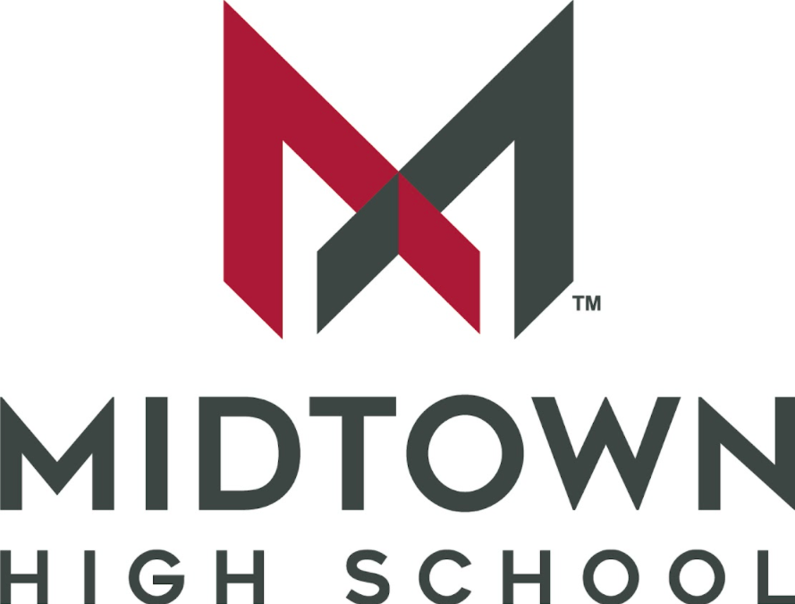

Receipt of Syllabus
Course Name: Financial Technology Services
Teacher Name: David Turner

______________________________ __________________________________
Student Signature Parent/Guardian Signature

______________________________ __________________________________
Date Date

